This series of short articles is reproduced from issues 99-102 (Oct 1986 – March 1987) of the Totley Independent
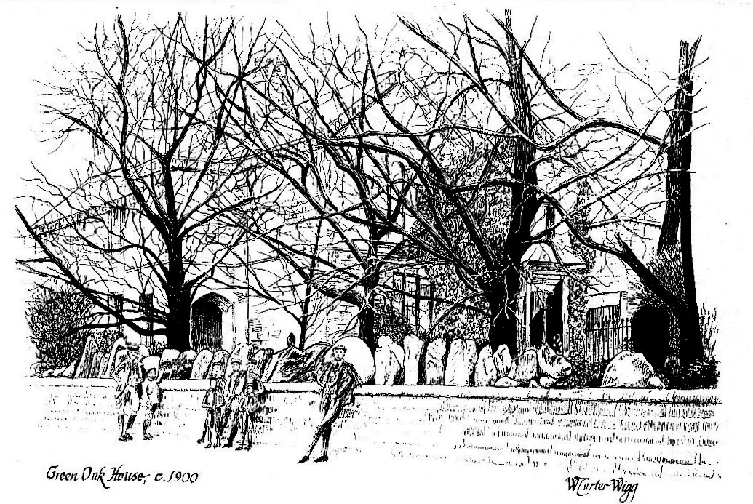

Reconstructed from a contemporary photograph showing A.C. Capron with Maurice and village boys.

GREENOAK HOUSE
By J. Deryck Bell
When nostalgia's ageless fingers beckon us backwards to well-loved occasions, we often recall them with more clarity than things which occurred a month a week or even a day ago. As we grow older, we are all similarly affected by this ebb tide of memory, which can trigger off a strong chain of associated images drawn out of the years, like a string of multicoloured handkerchiefs pulled magically and endlessly from some conjuror's hat. My good friend and correspondent, John T. Capron, who at 90 year, of age, the last living member of the Athol Capron family who Lived at Greenoak House, from 1899 to 1911, now living in North Yorkshire, has taken me on a privileged journey into nostalgia, recalling the times when he lived there and his subsequent life and adventures.
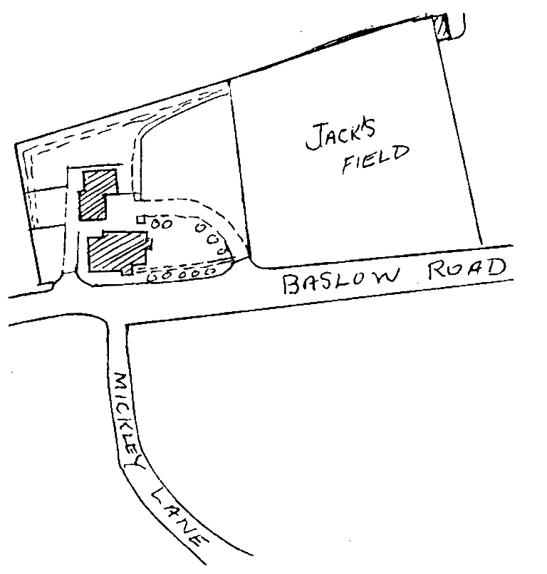
There must be few people living in Totley today who can remember Greenoak House as it was at the turn of the century, or even before 1914; then a family house, standing in its own grounds, with an adjoining paddock, separated from the road by a stone wall with beautifully fashioned and rounded capping stones, (some still to be seen on the wall fronting number 150 Baslow Road). Between this dwelling and the off-licence, was the original driveway entrance to Greenoak House.
In 1899, Athol Capron, a well-qualified and experienced engineer from Erith in Kent, came to Sheffield with his wife and four children, to take a management job with Davy Brother's Boilermakers, then an almost bankrupt company. He took his family (complete with donkey and cart), to live at Greenoak House, which he rented from Ebenezer Hall of Abbeydale Hall, for £90 per annum. They arrived in a bitterly cold February and were quite unprepared for the bleakness of the snow-covered Derbyshire moorland, after the much softer climate south of the Thames. After the first shock they soon settled in and as spring and summer came, they came to love the area. The donkey was put to graze in the paddock, which from then on was called Jack's field. At that time there were four children.
Maurice aged 9, Dosy (Dorothy) 7, John T. 3 and Gerard 1 year old. In 1903 their last child, Clare was born at Greenoak.
Athol and Catherine Capron were a well-balanced and devoted couple, very good to their children. He was calm, strong and firm, but a kindly v man; she was lively and intelligent and to the children she was more like an elder sister; well educated, fluent in French and German, she had a big influence on their early education, often reading aloud to them from Walter Scott and several French stories. A firmly-based and loving family.
Being a man of great energy, Athol Capron left Greenoak early every morning on a bicycle, sometimes catching a train at Dore and Totley station, but often he would ride right through to Park Iron Works. An old toolmaker told John Capron that his father was the only man he ever saw bicycling with an umbrella up! He Look to Davy Brothers his expertise, inventiveness and energy and did a wonderful job building up the firm from near liquidation. When he became Managing Director, he steadily expanded the engineering side, which was fortuitous for much later, when war broke out in 1914, they were able to produce vast amount of presses and shell-making machinery.
Every summer, Mr and Mrs Capron would invite .all the staff and foremen of Davy Brothers to tea games and supper; 25 to 30 would arrive in charabancs at Greenoak House. The supper was laid out in the large old coach house, which would be decorated by Dosy and John, mostly with foxgloves gathered from the wood overlooking Totley Brook: a busy time for all the family, but great fun. On one occasion, young Gerard caused some hilarity, when carrying replenishments of bread and butter across the lawn, oblivious of the fact that the plate in his hand was so angled that he was leaving behind a trail of bread and butter, his gaze being fixed on the assembled company.
Here was another Athol Capron family, for he was really loved by all the Davy Brothers people. Not only was he keen on and encouraged apprentices, but did everything he could to help the foremen, being foremost in getting a large house in Burngreave Road as a Club House for the Foremen’s Mutual Benefit Society.
Davy Brothers apart, he became the leader of all the other and much bigger Sheffield
Steel and Engineering Employers and for years was President of their federation, chairing endless committee meetings and conferences with the unions; not an easy role for some of the larger firms' directors were often jealous and awkward. Fortunately he had good reputation with the Unions; they knew that he was fair and also a practical man who could go on the machines, as well as being a first class carpenter. He had the reputation of being the most stubborn man in Sheffield, which is saying quite a lot (stubborn men not being uncommon in the Sheffield Steel Trades) and no doubt he needed to achieve what he did.
Mr Capron, a very busy man, did not see much of his family during the week, but on Saturdays in the summer he would often hire an open top landau from Mr Wint of Dore and Totley station and a Wint son would drive the family to the Peacock at Owler Bar, or to Fox House, where they would take long country walks, for they were very much an open air family; their driver would wait at: the inn for their return.
Athol Capron was a very public spirited individual with boundless energy, who it seemed, could turn his hand to anything, being involved with Hospital Committees and an active member of the Totley Parish Council, along with Squire Ellison, W.A. Milner and farmer Creswick, probably the four most active members of Parish Meetings.
At one time he bought a farm at Holmesfield, part of Woodthorpe, meaning one day to retire up there, but he never did. Instead he built a large stone house near Hathersage and in 1911 the family left Greenoak and went to live there.
About 1930, Firths and John Brown put capital into Davy Brothers and eventually took over. Jealous Directors of these firms soon had Athol Capron out. Fortunately good friends in the thriving Newton Chambers Company invited him to join their Board, where he worked happily until he retired. He died at Hathersage in 1937, followed by his wife in 1939.
End of part 1

Part 2
Young Caprons of Greenoak
One of John Capron’s earliest memories was at being “lost at Dore”, about 1900; being taken in a double pram with his brother Gerard, to explore “wilds of Dore”, by 2 ladies, who got lost. They must have travelled miles in wrong directions and when darkness fell they panicked, a panic which was felt by John, but they ploughed on and finally their way back to Greenoak; the 2 children being soothed down with dollops of golden syrup.
Another early memory was of going into his father’s dressing room into the tower which opened out from his parents’ bedroom to watch him shaving with a cut-throat razor. So fascinated was he that he took to going in every morning to watch the operation, whilst outside and overhead was the endless chatter of starlings, either making their nests or flying past the window.
Greenoak was at that time deep in the heart of the countryside and John remembers a certain air of peacefulness in the environment; of being awakened in the morning to the song of thrushes in the lilac bushes by the entrance of the yard gate and of going to sleep to the drowsy churr of corn crakes in Jack’s field.
He and his younger brother Gerard with very good friends and companions; Morris their elder brother either being away at boarding school at Matlock or later apprenticed at Vickers. When John was 7, he took charge of the few poultry they kept, a chore which he enjoyed. The 2 boys kept rabbits in the wooden hutch in the yard corner opposite the coach house, occasionally letting them out in Jack’s field.
Roaming through the wood overlooking Totley Brook Road and fishing for sticklebacks and loach in the brook was a constant delight. They were also great cyclists riding as far as Southwell, Lincoln and often up to watch work on the Howden Reservoir.
With the family, they went for long moorland walks on forbidden drives and footpaths. Their father knew Payne Gallwey, the Duke’s agent, who gave him a key to the gates, so they could wander at will, defying keepers if challenged, which they often were. Keepers in those days were far more aggressively active in keeping people out, bearing no resemblance to Seth Armstrong of Emmerdale Farm! Mr Green, a Totley Postman, used to cut John and Gerard’s hair, placing a bowl over their heads to get the correct shape and then blowing the hairs away. They waiting his powerful buffs on their skin and eventually they were taken to a hairdresser to Purkiss, who had a shop near the Town Hall in Sheffield. There were 2 doctors in the area, Doctor Parsons, who lived at the first house on Totley Brook Road and their own Doctor Thorn who lived in the Beauchief area and visited them at Greenoak in a dog-cart. Doctor Parsons had a car, which failing to fire one day, was stuck on the road just outside their backyard gate. The young Caprons all poured out and enjoyed pushing him towards Totley Rise, when after about 50 yards it fired and off he spluttered back to his surgery. Doctor Parsons always wore an overcoat with a high fur collar; the children thought he looked like a vulture perched high up and peering overhead!
John remembers many people and families who lived in the area before they left. The young Caprons in their tender years felt in some awe of the Milners of Totley Hall who were always graciously kind, inviting them to several annual “occasions” at the Hall; One being the visit at “daffodil” time, when they were taken around the garden by Mrs Elsie Milner herself. They liked her; she was nice and not too formal. Sometimes they joined Marjorie Milner, the only daughter, who drove the 2 boys in a giant sized wash basket mounted on wheels behind an agile young brown donkey, called Betsy, down the lane and along rough cart tracks before the woods. Marjorie, a veritable “Tottinglei Boadicea”, stood up to drive, urging on the young donkey to greater speeds with shouts of “WHY OH BETSY”, while their poor sister, Dosy, lumbered after them, driving their poor old Jack in the more conventional pony cart. They liked Roy Milner but were frightened of his older brother Billy. Some years later in 1914, early in the war, Roy was killed in action; a terrible local tragedy.
Not far from Greenoak lived the Earnshaws of Totley Grange and the Ellisons who owned the big house down Hillfoot Road, almost opposite Penny Lane.
John will never forget going to a party there and being coerced into dancing, ploughed manfully around the room with Mrs Ellison, treading so heavily on her long black silk skirt she immediately cast him lose!
Down the lane (as they always called it) leading to Mickley were quite a few cottages, mostly inhabited by railway employees; Cook, signalman; Nunn, gardener “later, signalman and “Jack of old trades”” and old Mr Wing who kept an Alsatian. Another Totley man was Jim Marshall who was their gardener and handyman. His young son Neville was often round at Greenoak helping out. The vicar at Abbeydale was J A Kerfoot and the one at Dore, Rev Gibson, who had 2 daughters, Queenie and Violet and a son Claude. Athol Capron sometimes walked up to Holmesfield Church where the vicar was old Mr Bradshaw. John recalls the small open bus running to and from Cross Scythes and the station; a one horse affair driven by Jim Larder, a curly black haired lively character, always full of repertoire, especially with the lady passengers.
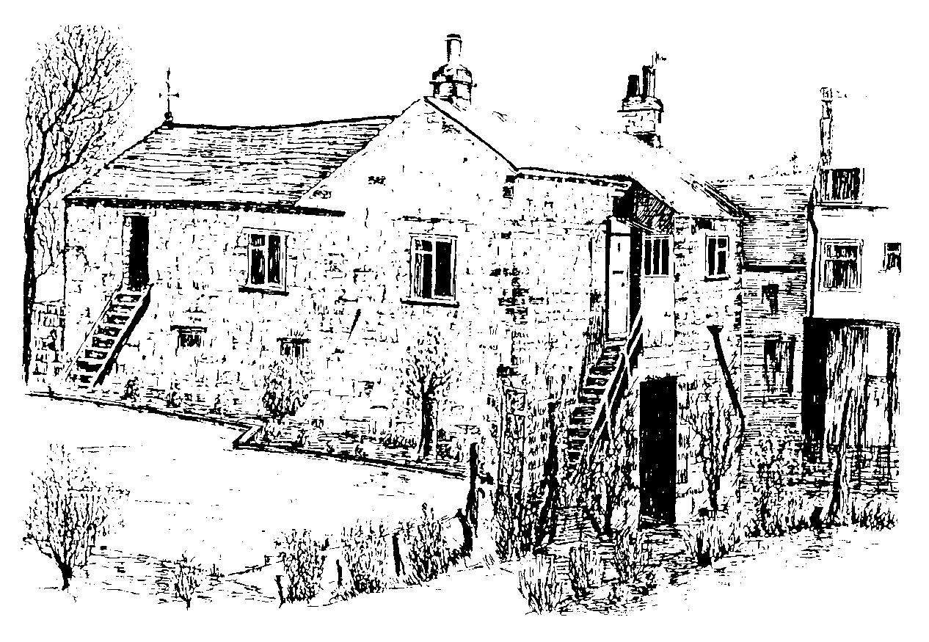
The Old Coach House, Greenoak House
Before they left Greenoak John and Gerard were promoted to rat catching using an air gun and traps. They had an exciting field day when Colin Thompson from Totley Rise “an elegant and dashing butcher who hunted and rode a spirited horse” brought ferrets and a dog to clear rats from the old barn beyond Jack’s field and their stable block. They really loved living at Greenoak and always understood it had been the Toll Bar House.
In many ways they were sorry to leave but their father had the urge to build himself a good stone house further into Derbyshire, only 25 acres, at Outseats, just clear of Hathersage and convenient for him to take the train to Sheffield
End of Part 2.

Part 3
John O’Greenoak
Both John and Gerard had been educated at home until they reached 10 years of age, when each boy was sent to a boarding school in Oxford where their father had been educated. Later they continued their education at Wellington College, again following their father’s footsteps. It was here that Gerard, a very independent character, did not conform regularly to the etiquettes of the college, where individuality was frowned upon. One night with another wild spirit, he took a night ride to Reading after lock-up. On returning, he climbed the high tower and set the clock hands back! Found out, he was kept back for 2 days at the end of term and John, often caught in the crossfire of his younger brother’s misdeeds stayed on with him. When war broke out in 1914 John joined the college training corpse and in Sheffield his elder brother Maurice, now an engineer at Davy Brothers, had a promising career ahead, volunteered for the army. Much to his sorrow he was turned down to a varicosed leg condition and for the same reason he left Davy Brothers and went into pig breeding in Lincolnshire with some success. He pioneered open air pig breeding and marketing before the intensive era. His wife, of typical Lincolnshire farming stock, was a great help to him and died only recently 104.
In November 1915, when junior officers were falling like 9 pins in France, John, just 19 years of age and in his last year at Wellington, was surprised to learn that he had been granted a Commission in the Field Artillery (RFA) as second Lieutenant and must report to his Training Brigade with the 49th (West Riding) Division at Ripon on the 1st January 1916. Feeling rather a fraud because he was only a private in the College Corps, he made a hurried departure from Wellington in order to get kitted out in Sheffield to meet the deadline at Ripon. So, second Lieutenant John T. Capron, like many other “soldat malgré lui”, arrived at Ripon Station on 1st January 1916 and “proceeded” through the town to quarters near Studley Royal Park. Passing various “other ranks” on route he was more than embarrassed at having to acknowledge their methodical salutes, something he escaped in France at least in the battle areas, where saluting was not required.
He enjoyed training with the 49th West Riding Division learning to ride and to bring their 18 pounder field guns into action “open warfare”, over the fields and woods of Studley Royal and Galphay. Training alongside them was the Northumberland Artillery and the “Geordies” was his future brother-in-law, Bertie Claudet, who had already out and wounded whilst serving of the ranks HAC. He was given a Commission on coming out of hospital in Sheffield, where in fact he met and later married Dosy.
During the Somme holocaust of 1916 John was drafted out with other reinforcements to the 56thLondon TA Division, which had suffered heavy losses in the July attack. He served a year with their Ammunition Column, which involved endless ferrying shells by night convoys of horse and mule-drawn limbers over the dreadful aftermath battlefield of the Somme. In the autumn when the mud got too deep for the wagons the 18 pounder shells were packed into canvas panniers, 4 each side, slung over the animals backs. Each driver lead, or more often dragged his reluctant pair, under cover of night, 3 or 4 miles from the “dump” to the gun-site.… A far cry from the peace of the Ripon countryside!
In September 1917 John was posted to the 109 a regular 18 pounder battery defending the lines at Arris, their guns being deployed in the shunting yards. It was in that beleaguered town near the station that John was wounded and sent down to hospital at Paris Plage with shell splinters in the head and right thigh. A month later he was back with the 109 battery. Their worse was 29 March 1918, when the Germans made their last great attack, bending the 5th army, but not breaking through. They were holding the line in from of Arris, a key point, and were under intermittent barrage for 17 hours. Four of their 6 guns were knocked out and 2 sergeants and several of the gun crews were killed.
Towards the end, the war had been fast- moving, open warfare, the old trenches of the Hindenburg Line, before Arris left far behind. The battle-scared 109 battery fought on, most days moving forward covering defence and attack and coming into action several times between dawn and dusk. The command of the now depleted battery was shared amicably by John and 2 other young subalterns, their being no senior officers left. All 3 were “Mentioned in Despatches” and recommended for decoration.
The battery finished up on 11 November 1918, Armistice Day, a few kilometres south of Mon, where in August 1914, they were probably the first 18 pounder guns to open fire in defence of the bridge and the barricades there. John stayed with the battery until demobilised and was out of the army by Easter 1919.
End of Part 3

Part 4
Return to Greenoak
When a young soldier battle-scarred and weary returns home having passed “through the mud and blood to the green fields beyond”, life for him for will never be quite the same again. He may find those fields not quite so freshly green as he had imagined, but rather ready for the resowing. So it was with John Capron, being country-bred and a country-man at heart, he decided that his future lay in farming, so to that end he enrolled at the Shropshire Agricultural College. There on the college he met Ruth Adam, who in fact taught him how to milk. They were married at Kidderminster in 1922. Unable to raise enough capital to get into farming he returned to the Totley area, where they bought a small stone house at Holmesfield and John became articled to a solicitor in Sheffield.
His route to work was quite arduous, down Holmesfield wood, striking left over to the fields at Totley Hall Lane, to catch a bus to Dore and Totley Station for a train to Sheffield; returning in the evening by the same route, often laden with household goods and food, which Ruth was unable to obtain at Mellors, the only shop in Holmesfield. A very tiring time for John, who having worked all day spent most nights studying for his law exams.
One night a young man sneaked into the house and stole John’s case which he had left in the hall. Fortunately their dog stopped him getting away and on John arresting him the young burglar asked to be taken into custody. So tired as he was and having no telephone John had to make a second journey that day down the fields to Totley Police Station, where the young miscreant got a bed for the night. On the way down John had wondered if the lad would make a break for it and he did not and by the time they had got to the police station John was feeling sorry for him; a sad case, unemployed, bad home background, quite rudderless. John had to go to court of course, but was pleased the lad got off lightly.
During the period 1922 to 1927 when articled in Sheffield John, at his father’s invitation, went down to Park Iron Works at Brightside every day to have lunch in the staff dining room. Their Athol Capron presided at the head of a table seating about 16, carving a hot joint with 2 veg, followed by some solid pudding. A friendly family gathering; a relationship which extended throughout the firm, small wonder there was no industrial unrest at Park Iron Works. Athol Capron had been awarded the OBE for his services during the war and in 1931 was made a Justice of the Peace for the City of Sheffield. By 1927, John, now 31, having pass all his law exams left Sheffield with Ruth and their daughter Jane, born 1923, and took a position at an old established firm of solicitors in Norfolk. There he stayed until Hitler’s war when in 1940 still on Army Reserve he was recalled to the Army serving on Coastal Defence with naval guns at various positions from The Orkneys south to Lowestoft until the war was over and he was once again “demobbed”. Thereafter, he started on his own near the Norfolk Broads, carving out for himself a very successful country practice.
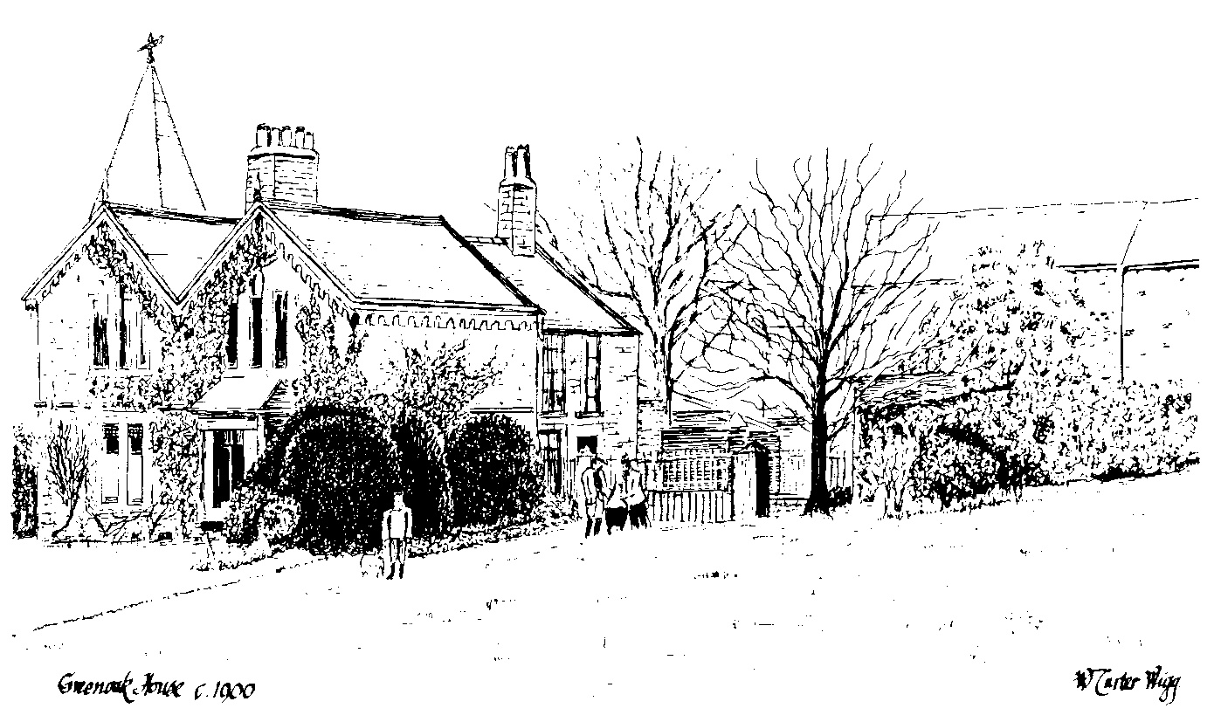
Meanwhile, until 1937 Athol and Catherine Capron with Gerard and Claire had been living at Westlow, the family home near Hathersage. Gerald excelled at carpentry and also did some fine wood carving.
Clare was deeply involved in country matters, a born naturalist, did very good flower sketches and was a wonderful bird mimic. Many people in Hathersage remember her talks and demonstrations. Neither Claire or Gerald never married.
They were devoted companions and lived together all their lives. When their parents died Athol in 1937 and Catherine in 1939, they left Hathersage and bought a smaller house at Brockenhurst in the New Forest, and Clare often made long summer visits to friends in Hathersage. On her last visit in 1970 (just before she died) she was accompanied by her 2 remaining brothers John and Gerard, when a friend drove them to see their old home at Greenoak.
When you return to a place after a long time, the difference between your memories and the realities you meet can be quite shattering. For memory makes no allowance for that greatest of all realities … change. Thus it was with the 3 remaining Caprons. At first they could not find their old home; it was nowhere to be seen. Not until they crossed the busy road to Mickley Lane and looked back did they see the beleaguered tower and their old home. Totally encapsulated in a shopping parade, and the paddock “Jack’s field” completely overbuilt. They were shocked into a bewildered silence, dazed and dismayed, John remembered that change inevitably hurts someone; he now finds comfort in the thought of so many new lives and families active and happy where they grew up; he sees evidence indeed of the community life and good fellowship in The Totley Independent itself.
When he retired in 1960, he and Ruth settled happily to village life in Gillamoor, North Yorkshire strategically between Hull and Scotland where their 2 daughters lived. They kept poultry and one favourite goat, and enjoyed involvement in local affairs. In 1984 came the death of brother Gerard and the same year John lost Ruth, the end of a 62 year partnership. He moved down to the small town of Kirbymoorside. Here in his small comfortable cottage, with good friends and neighbours he lives with his memories. Perhaps because of his legal training his early disciplines and teaching of his parents, John has lately developed a real craving to see justice in every walk of life.
He deeply regrets the tendency to overlook the claims of the victim in compassion for the criminal – with resulting punishments by the capital courts not fitting the crime. For all his 90 years he is still a prolific writer and constant contributor to The Yorkshire Post; John T. Capron (John O’Greenoak) a kindly, perspective, compassionate … a good friend, tres gentil.
The End

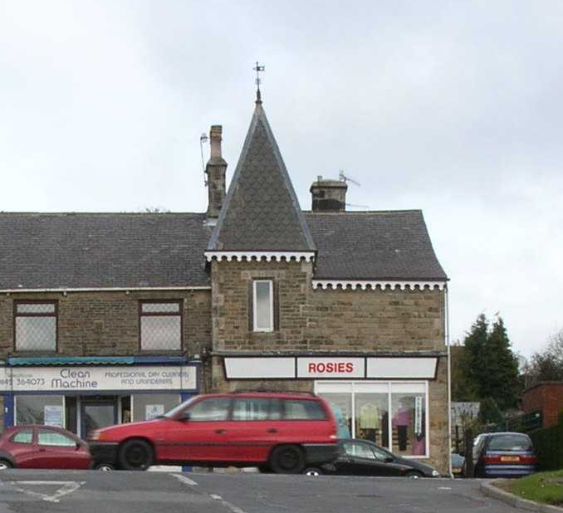
Greenoak House in the 21st Century

