TOTLEY SHOW RESULTS
September 2008
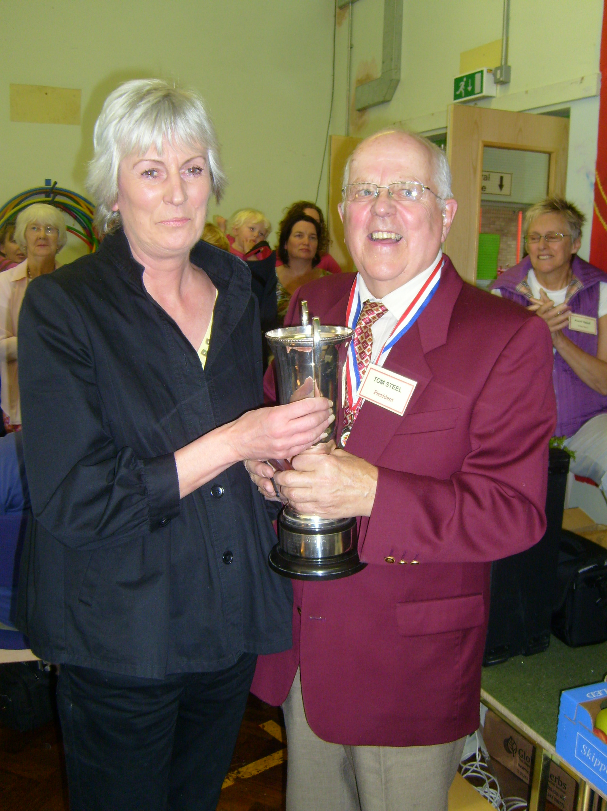

Overall Best in Show:- Kate Parkin .

Kate Parkin of Totley Brook Road receiving her trophy for Best in Show from Totley Show President Tom Steel. This was Kate's first time to enter anything in Totley Show, and her beautiful textile sculptures in Class 47 (Open Multi Media) won her the accolade from all the Show judges.

HANDICRAFTS. Best of Class:Sally Measures
 | FIRST | SECOND | THIRD
1. Hand Knitted Article | Christine Shimell | Jennie Street | Bet Warwick
2. Decorative Cushion | Sue Bridgens | Alison Harries
3. Soft Toy | Vivien Filleul | Hannah Corby | Sue Bridgens
4. Tapestry | John Elliott | Lillien Spivey | Alison Harries
5. Cross Stitch | Sue Bridgens | Margaret Williams | Marie Page
6. Collage
7. Greetings card | Anne Hart | John Elliott | Ann Powell
8. Open handicraft | Sally Measures | Claire Rose | M Andrews

DOMESTIC SECTION. Best of Class: Jo Connolly
 | FIRST | SECOND | THIRD
9. Victoria Sandwich | Ann Lee | Rachel Walkden | Sue Bridgens
10. Dundee Cake | Duncan Froggatt | Sally Goldsmith | Brenda Wise
11. Carrot Cake | Jo Connolly | Barbara O’Connor | Sue Bridgens
12. 3 savoury scones | Tom Steel | Sally Goldsmith | Lynda Liddle
13. 5 biscuits | Charli Buxton | Ciara and Rebecca | Dorothy Firth
14. Apple Pie
15. Loaf of White Bread | Martin Harpham | Peter Woodcock | Sally Goldsmith
16. Jam | G Skinner | Richard Farnsworth | Clare Rundell
17. Lemon Curd | Katrina Watson | Lynda Liddle | S Goldie
18. Marmalade | Rebekah Newman | Jennie Street
19. Chutney | Christine Shimell | Duncan Froggatt | Leigh Miller

FLORAL SECTION. Best of Class: Elizabeth Walkden
 | FIRST | SECOND | THIRD
20. Table Dec. Fresh to 6” | Katrina Watson | Elizabeth Walkden
21. Table Dec. Fresh 6”+ | Elizabeth Walkden | Jane Needham
22. Posy of flowers | Lynda Liddle | Jennie Street
23. 3 Cut Flowers | Pauline Perkinton | Peter Bradshaw | Jennie Street
24. Foliage Plant in pot | Avril Critchley | Lynda Liddle | Pam Voice
25. Flowering plant in pot | Pam Voice | Elizabeth Walkden | Catherine Wrigglesworth

FRESH PRODUCE. Best of Class: John Plumridge
 | FIRST | SECOND | THIRD
26. 4 Eating Apples | Danny O’Connor | Oliver Walker | Tom Steel
27. 4 Cooking Apples | David Corby | Danny O’Connor | Rita Garnett
28. 8 Blackberries | Harry Liddle | Alice Dowling
29. 4 Matching Potatoes | Jennie Street | Jennie Street | Henry Willison
30. 3 Matching Leeks | John Plumridge | Tom Steel
31. 3 Matching Onions | Tom Steel | Henry Willison | Allen Miller
32. 6 Mixed Veg. | Henry Willison | Jennie Street | John Plumridge
33.5 Matching Runner Beans | Danny O’Connor | Catherine Wrigglesworth | Catherine Wrigglesworth
34. 5 Tomatoes | B M Mettam | Tom Steel | John Perkinton
35. 1 Cucumber | Jennie Street | Danny O’Connor | Alan Lee
36. 3 Courgettes
37. Largest Onion | Tom Steel
38. Heaviest Marrow/squash | John Plumridge | Bruce Willison | Katrina Watson
39. Longest Runner Bean | Catherine Wriggleworth | Jennie Street | Tom Steel
40. Miscellaneous Veg. | Katrina Watson | Jennie Street | Katrina Watson
41.Tastiest Tomato | Bruce Willison | Katrina Watson | Jennie Street
42.3 matching eggs | Bruce Willison | Jennie Street | Lucy and James Farmer

ART. Best of Class: Roy Hutchinson
 | FIRST | SECOND | THIRD
43. Oil or Acrylic Painting | Roy Hutchinson | Angela Harpham | Valeria Wrigglesworth
44. Water Colour | Gerry Doherty | Roy Hutchinson | Gerry Doherty
45. Pen & Ink Sketch | Anne Hart | John Hammond | Connie Froggatt
46. Pencil Sketch | Doreen Scotton | Elaine Wallis
47. Open Multi Media | Kate Parkin | Gerry Doherty | Anne Hart
48. Reclaimed art/sculpture
49.Sculpture any medium | Avril Critchley | R Sables | Kate Parkin

PHOTOGRAPHY. Best of Class: Carol Munday
 | FIRST | SECOND | THIRD
50. Colour | Carol Munday | Tom Steel | Sue Bridgens
51.Black and White | Tom Steel | Angela Harpham | John Hammond
52. Computer Art | Les Firth | Avril Critchley | Avril Critchley
53. Totally Totley | Anglea Harpham | Fiona Oxley | Avril Critchley

WOODWORK. Best of Class: J D Andrews
 | FIRST | SECOND | THIRD
54. Wood Turning | J D Andrews | Martin Harpham | Martin Harpham
55. Small Furniture | J Morgan | Chris Caroe
56. Wood sculpture | J Morgan | Hazel Perfect | Martin Harpham

CHILDREN’S SECTION. Best in Class: Alex and James Buxton (up to 7), Thomas Giles (up to 14)
 | FIRST | SECOND | THIRD
57. Animal Veg. Up to 7yrs. | Alex and James Buxton | James Caroe | Elizabeth Mill
58. Miniature Garden 8-12 | Taylor Hawkins | Peter Rose | Charlotte Bridgens
59. Computer Art up to 8rs
60. Computer Art 9-14yrs | Luke Bale | James Bridgens
61. 3 Decorative Buns | Alex Scott | Charlotte Bridgens | James Bridgens
62. A wibbly wobbly jelly | Charlotte Bridgens | James Bridgens
63.Flower arrngmt in eggcup | Charlotte Bridgens | James Bridgens | Saron Awet
64. Painting under 5yrs | Emma Caroe | Saron Awet
65.Painting 6-11yrs | Joanna Bale | Charlotte Bridgens | Joanna Smith
66.Painting 12-14yrs | Ben Sockett | Daniel Bale
67.Lego model 5-8yrs | Jo Frost and James Rose | George Frost and Alfie Langley | Oliver Walker
68.Lego model 9-14yrs | Thomas Giles | James Wilson | James Bridgens
69.Colour photo | Joanna Smith | Aidan Smith | Ben Sockett
70. Children’s Open Craft | James Rose | Charlotte Bridgens | Saron Awet

Many Thanks to all who so generously supported the Raffle at the Totley Show. Especially local businesses.
The Ironing Parlour, Totley Pharmacy, Baslow Rd., Rosie, The Co-op, Totley Rise Post Office, Totley Rise Newsagent, Totley Deli Totley Gifts and Flowers, Abbey Friar, Martin Scrivens, The Luxury Gap.

